# Automated Teller Machine Web Application

Basic **CRUD** operations Application using:

ASP.Net MVC 5

Entity framework

**Created ASP.NET MVC 5 project**

* Login Page
* User Registration
* Home
* Withdrawal
* Balance Inquiry
* Transfer Funds
* Print Statement
* Deposit
* Quick Cash
* About
* Contact

Controllers

* Account
* Checking Account
* Create Account
* Update Balance
* Account Details
* Home
* Transaction

Test cases:

* Check Controller Action Method
* Provide Message in Contact
* Check Balance After Deposit

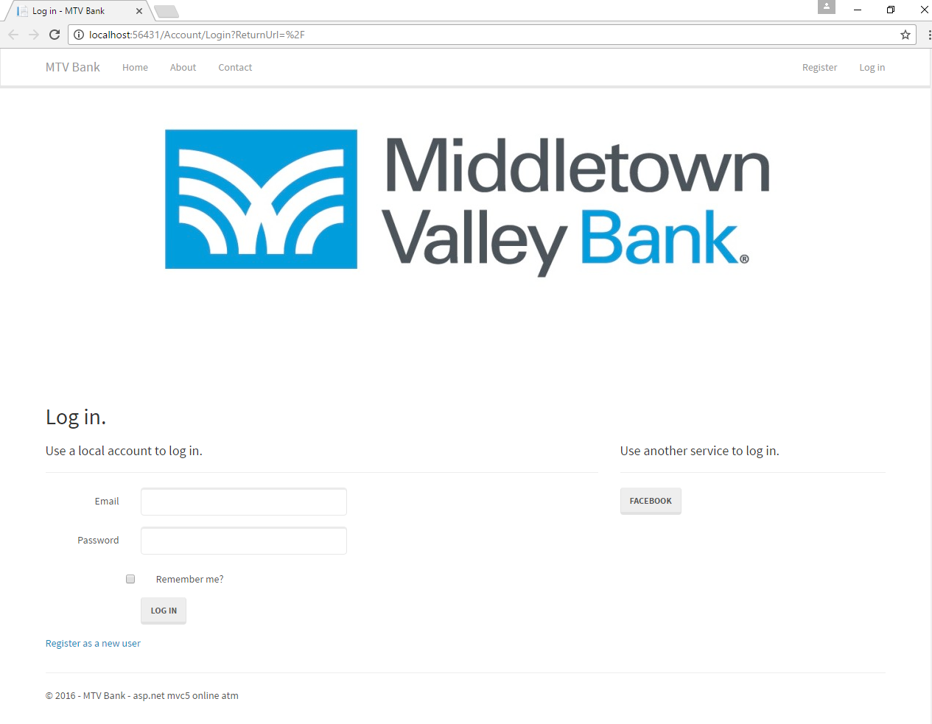

**References**: MSDN, ASP.net and <https://weblogs.asp.net/>